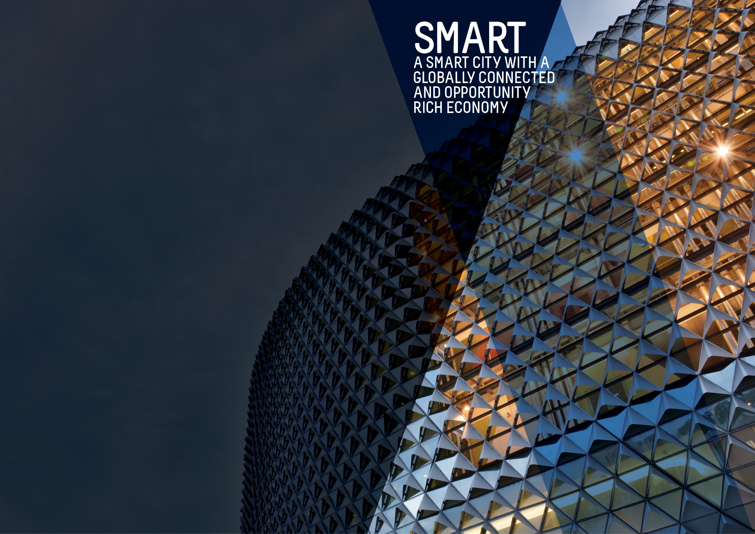
Second Quarter Report 2018-19

OBJECTIVES SUMMARY
The Smart theme has four objectives. Updated data was available for one of the objectives during the quarter.
ACTIONS SUMMARY
Of the 26 actions under Smart, 18 were on track, four were on watch, one was off track, and three were complete at end Q2 2018/19.

18  ON TRACK |  | 4  ON WATCH |  | 1  OFF TRACK |  | 3  COMPLETE

OBJECTIVE | UPDATE | STATUS
BY 2020, OUR CITY’S ECONOMY WILL BE GROWING FASTER THAN THE AUSTRALIAN ECONOMY | In the year to 30 June 2018, the city's economy grew by 2.1% from $18.0 billion to $18.4 billion. In comparison, South Australia's economic growth was 1.8% over the year while national economic growth was 2.8%.  Since the introduction of the City of Adelaide' 2016-2020 Strategic Plan (the Strategic Plan), this is the second consecutive occasion where national economic growth has exceeded the economic growth of the city.  Data source: National Institute of Economic and Industry Research (NIEIR) 2018, presented by economy.id | BASELINE:  GRP growth 2.4% (June 2014)  GDP growth 2.5% (June 2014)  UPDATE ON OBJECTIVE:  GRP growth 2.1% (Jun 2018)  GDP growth 2.8% (Jun 2018)  NEXT UPDATE: 2019  DIRECTION OF CHANGE: unfavourable variance
TOTAL BUSINESSES IN THE CITY WILL GROW FROM 5,000 TO OVER 5,300 AND WORKERS ON ANY GIVEN DAY FROM 89,000 TO 94,000 BY 2020 | The number of workers in the city has continued to increase from the baseline figure of 89,000 although at a slower pace compared to previous years. In 2018, there are an estimated 91,500 workers in the city on an average weekday.  There has been no updated data for the number of businesses in the city since Quarter One 2017/18.  Data source: City of Adelaide Census of Land Use and Employment (ACCLUE) 2016; City of Adelaide City User Profile (CUP) Survey 2016; ABS, ‘Regional Population Growth, Australia, 2014-15’ (Cat. No. 3218.0) | BASELINE:  89,000 workers daily (2014)  5,055 city businesses (2014)  UPDATE ON OBJECTIVE:  91,500 workers daily (2017)  5,196 city businesses (2016)  NEXT UPDATE: April 2019  DIRECTION OF CHANGE: favourable variance
WORKERS IN PROFESSIONAL AND TECHNICAL SERVICES, EDUCATION, FINANCE, TELECOMMUNICATIONS, CREATIVE AND MEDIA SECTORS WILL HAVE GROWN FROM 41,000 TO OVER 49,000 | The number of workers employed by knowledge sector establishments fell by 12% from 40,279 people to 35,650 and is due to a decline in employment across all the knowledge industries. The largest decrease was in the Professional, Scientific and Technical Services sector (-1,968) and the Information, Media and Telecommunications sector (-1,802). This is likely to be due to the reduction in the city-based Telstra workforce and the reduction/amalgamation of internet service providers (ISPs) since 2014. (Last updated Q2 2016/17)  Data source: City of Adelaide Census of Land Use and Employment (ACCLUE) 2016 | BASELINE:  40,700 workers in knowledge sectors (2014)  UPDATE ON OBJECTIVE:  35,650 workers in knowledge sectors (2016)  NEXT UPDATE: TBA  DIRECTION OF CHANGE: unfavourable variance
BY 2020, THE NUMBER OF STUDENTS IN THE CITY ON ANY GIVEN DAY OF THE WEEK WILL INCREASE FROM 39,000 TO 41,000 | In 2017, there were approximately 43,000 students in the city on an average weekday. This represents a 7.5% decrease from the number of students in 2016 and could be due to the increasing prevalence of online courses and delivery modes that make it easier for students to study off-site. Nevertheless, student numbers of 43,000 continue to exceed the 2014 baseline total of 39,200 students in 2014 and the target of 41,000. (Last updated Q4 2017/18)  Data source: City of Adelaide City User Profile (CUP) Survey 2018; ABS, ‘Regional Population Growth, Australia, 2016-17’ (Cat. No. 3218.0) | BASELINE:  39,200 students daily (2014)  UPDATE ON OBJECTIVE:  43,400 students daily (2017)  NEXT UPDATE: April 2019  DIRECTION OF CHANGE: favourable variance

ACTION | RESPONSIBLE OFFICER | UPDATE | STATUS
Adopt smart technologies that demonstrate a clear return on investment through new recurring revenue generation models such as; sourcing of external funding, fee for services, data, intellectual property, licensing, proprietary technologies, sharing of services and efficiency dividends | Associate Director, Information Management | The Cities of Playford and Salisbury are considering prior discussions held with CoA regarding possible fibre connections. Three existing Connected Councils have approached CoA regarding cost-effective sharing of the organisation’s existing Cloud Connection, which will also provide the organisation with cost savings and other collaboration opportunities. | on track
Assist businesses and institutions to attract talent by developing and making available collateral promoting Adelaide as a great place to work and live | Associate Director, Economic Development & Tourism | Fourteen success stories have been written and placed on the Invest Adelaide website. These stories are broad ranging, covering technology, business expansions, examples of business confidence, new investments, business awards and major conferences. These stories have been promoted through various social media channels such as the Lord Mayor and City of Adelaide accounts and the personal accounts of relevant staff. The stories were also referred to in the Enterprise Adelaide e-newsletter. Referral traffic created from these stories is a key source of traffic for the website. Investigations have continued to improve and add new features to the Insights resource on www.investadelaide.com.au. | on track
Become a world-renowned education City by supporting and partnering with the City’s education sector to attract and retain international, national, regional South Australian and local students, and highly credentialed academic and research staff | Associate Director, Economic Development & Tourism | While the Lord Mayor’s roundtable for the education sector did not go ahead in this quarter as planned, Council continues to leverage opportunities for international students as part of the International Relations review currently underway. Associated events, activities and programs will commence following the completion of the review dependent on review recommendations. | off track
Bring together the creative, arts, business, university, education and entrepreneurial sectors to promote unique opportunities for business growth | Associate Director, Economic Development & Tourism | The opportunity to leverage the long-term benefit of international students to city growth has been included as part of the scope for the International Relations review which is currently underway. Any arising relevant recommendations will be progressed following the completion of the review. | on Watch
Build upon the growing laneway and entrepreneurial culture in the City by rejuvenating primary laneways and pedestrian connections. Priorities for completion by 2018 will be the Adelaide Railway Station to Adelaide Central Market link and Rundle Mall laneways, including Gawler Place (ANNUAL OBJECTIVE) | Associate Director, Strategy & Design | To build upon the growing laneway and entrepreneurial culture in the city, works have continued on Bentham Street to progress the delivery of the Market to Riverbank link. The Gawler Place Project will proceed following Council approval for $16.9 million in Quarter Two and investigations and preliminary designs are currently underway for various laneway activation projects across the city. | on track
By June 2018, as part of an improved customer experience we will develop a business plan and implement smart parking technology across the City and North Adelaide to move towards an expiation-free environment | Associate Director, Information Management | Implementation of smart parking technology was completed and the Smart Parking project is expected to go live in late January 2019 in spite of delays with supplier testing. The Park Adelaide App and reporting systems are currently being finalised. | on watch
By June 2018, develop and promote an international City brand that showcases the smart, liveable, green and cultural advantages of Adelaide | Associate Director, Marketing & Communications | The City of Adelaide Brand story "Designed for Life" is being successfully integrated into marketing and communications activity across the organisation and is also being shared with key stakeholders across the city. The Adelaide city story is nearing completion and will form the central narrative for sharing with the wider community and interested stakeholder groups. Further campaigns and initiatives are also being developed to increase understanding and use of the Adelaide city story across council, community and stakeholders who have a shared interest in promoting Adelaide. | on track
By June 2018, leverage, upgrade and expand our AdelaideFree WiFi network to higher download and upload speeds | Associate Director, Information Management | Opportunities to expand and improve the AdelaideFree Wi-Fi Network will now be investigated through potentially leveraging the 10 Gigabit Adelaide infrastructure.  This Action will therefore be closed out and no further updates provided for the remainder of the City of Adelaide 2016-2020 Strategic Plan. | Completed
By June 2017, review Council’s commercial operations to determine the best management models | Associate Director, Commercial | A range of reports have been provided to Council relating to each of Council’s businesses identifying both strategic and operational issues and opportunities. Further strategic and operational reports for each ‘city business’ are scheduled to be presented to Council. Preliminary discussions have occurred regarding options for governance structures. An external consultant has been engaged to consider options and proposed approaches that may also inform legislative changes. | on track
By June 2018, work with key stakeholders in mainstreets and districts to develop business plans that will provide greater participation at the local level and appropriate governance models, as well as work on projects such as an O’Connell Street enhancement program | Associate Director, Economic Development & Tourism | Following the receipt of reports and acquittals, the 2018/19 Mainstreet Development Funding was provided to the seven Precinct Associations. Representatives from the Precinct Groups, Rundle Mall Management Authority, Renew Adelaide, Adelaide Central Market Authority and Chinatown Association South Australia attended the Lord Mayor's Precinct Forum providing insights to issues and challenges in their specific areas.  City of Adelaide continues to work closely with the seven Precinct Groups assisting with Christmas funding, Christmas activation delivery, and acquittal processes. Support and guidance was provided for the new Precinct Board members following the Precinct Annual General Meetings during this quarter and leading up to the Local Government elections. Forums were facilitated to address declining business numbers in O'Connell and Melbourne Street. | on track
By June 2020, increase the City’s share of the retail and hospitality sectors and deliver ten new high-end stores and 40 start-up businesses by delivering the ‘Experience Adelaide’ Adelaide City Retail Strategy | Associate Director, Economic Development & Tourism | Despite an application for Smart Cities and Suburbs Round 2 funding being unsuccessful, projects remained on track to see successful delivery. The assessment of digital customer services, social media feedback and data aggregation services has led to the trial of two SAAS services to be rolled out during Quarters Three and Four.  GovHack was supported through sponsorship prize money and access to City of Adelaide’s open data sets with eight entries showcasing the retail and hospitality businesses in interesting and innovative ways. For the Retail Beacons project, Brauz was made available to retailers in Rundle Street and surrounds but the uptake of the service has been slow and assessment of the service offering moving forward is ongoing. | on track
Council will continue to liaise and work closely with NBN Co in support of the NBN roll-out across the City | Associate Director, Information Management | NBN has significantly progressed its roll-out of the network across the city. Some areas in the northern and southern parts of the city have already received service while the majority of Adelaide will see service between April to June 2019. NBN has also updated the technology from fibre-to-the-basement to fibre-to-the-curb.  This Action is considered complete. | completed
Council will work with key partners to facilitate a 10GB per second capable broadband network across the City and North Adelaide to all premises (ANNUAL OBJECTIVE) | Associate Director, Information Management | Milestone Three for this project was achieved during this quarter with a total of 80 buildings now connected to the 10GB network. | on track
Each year, increase online open access to meaningful Council-held data and information that empowers residents, visitors, researchers, investors, start-ups and established businesses to make informed, smart decisions | Associate Director, Information Management | New sources of information for the Economic Insights Dashboard have been identified. A list of new indicators has been prepared and work on new potential reports to be added to the dashboard has started. During this quarter, CoA have also successfully tested new ways of collecting business data. | on track
Establish single-point-of-contact case managers to support established businesses to grow and attract sustainable businesses, investment and new corporate headquarters to the City | Associate Director, Economic Development & Tourism | The Case Management process (CM) continues to build an important level of engagement with key investor groups offshore, nationally and through external stakeholders particularly with the commercial property market, government agencies and Council programs with an interest in investment attraction. The last quarter has been dedicated toward client contact and management on active investment cases as well as servicing new cases, enquiries and general contacts.  The quarter has been characterised by continued investor interest in Adelaide, reflecting confidence in the market with ongoing impetus driven through the 10GB Adelaide initiative, collaboration with the Department of Trade, Tourism and Investment, engagement with the commercial property market, and investors from Singapore. Notably, there has been a diversity of activity ranging from local business engagement through to facilitating investment enquiries, capital transactions and development activity from corporate entities operating on a global scale. | on track
Facilitate development of the fastest growing sectors, including professional and scientific services, arts and creative industries, by engaging with business leaders to foster collaboration and to assist in identifying and responding to opportunities and challenges | Associate Director, Economic Development & Tourism | The remaining programs of the Adelaide Smart City Studio have continued in this quarter. The WaterTech and FestivalTech funding deed acquittal has been extended to 30 June 2019 allowing teams to continue their commercialisation progress. The monthly Smart City newsletter continues to be distributed to 1,000+ subscribers.  GovHack and Southstart were sponsored while Techfugees and other events will be supported in 2019. Plans are underway to generate increased use of the Studio space by start-up community groups. | on track
From 2016 to 2019, increase activity in underutilised premises by providing three years' financial support to Renew Adelaide | Associate Director, Economic Development & Tourism | This period has seen nine properties activated with a range of businesses supported. This underpins Renew Adelaide's vision for a diverse and varied economy where new ideas are embraced and the city is seen as the premier location to do this.  Businesses supported include Scullery, Adelaide's first Kombucha tap room; Flourish, focussing on technology-assisted mediation and mindfulness classes and the first project on Hutt St; and Solomon Street, a sustainably focussed fashion label based in Regent Arcade.  Over the past three years the success rate of moving from rent-free to a commercial lease is 50%. During this quarter, eight projects launched in previous periods graduated to commercial leases, an ideal outcome for Renew Adelaide assisted businesses. Furthermore, two of these eight businesses were launched on Melbourne Street, North Adelaide through a collaboration project with CoA. | on track
Promote opportunities and develop projects to showcase the City’s unique heritage and character as a catalyst for sustainable growth and to grow the heritage tourism market | Associate Director, Economic Development & Tourism | Existing heritage trails were maintained and distributed through the visitor centre, community centres and libraries. The trails are also being made available as interactive maps and itineraries online. In December, an old trail about theatres was put forward for digitisation and updating and will be online at the end of January.  CoA supported the National Trust SA with a Commonwealth Heritage Tourism Grant fund application during the quarter. Council has also committed to working collaboratively with the State Government, National Trust and other partners in the development of a Heritage Tourism Strategy. | on watch
Pursue a definitive outcome for the future of the former Royal Adelaide Hospital site as a world class precinct that complements the Park Lands, North Terrace cultural precinct and the East End commercial precinct | Associate Director Strategy & Design | This strategic action is now complete and can be closed. East End activations will occur as part of business as usual. | completed
Showcase the City as the location of choice for international and national trade and investment, especially for the knowledge, arts and cultural sectors, through our sister cities and other partnerships and connections, and align with State Government economic targets for increasing foreign investment, service exports and skilled migration. | Associate Director, Economic Development & Tourism | An external consultant has been contracted to complete the International Relations review and have commenced work. The review will focus on outcomes of past activity and what role CoA should play considering State and Federal Government roles. The review will also evaluate regions of focus, Sister City / Friendly City relationships and leveraging the international education sector for city growth.  A Creative Industries Investor Roundtable was held in December which was hosted in partnership with Colliers International. It was attended by 12 businesses from the Gaming Development Industry and resulted in several leads to follow up in having a presence in Adelaide or leveraging its business capabilities. The roundtable shared the benefits of operating in Adelaide, success in establishing a Gaming Development eco-system, and Ten Gigabit Adelaide. The roundtable was supported by the State Government and local business Cospective who recently won an Emmy Award for the Visual Effects editing technology.  Collateral was promoted among businesses, institutions and investment intermediaries and is available in hard copy and on the Invest Adelaide website. News stories and Economic Insights continue to drive website traffic. The information presented on Invest Adelaide is being reviewed in conjunction with reviewing the business content on the CoA website to reduce unnecessary information and allow the information to be accessed more easily.  CoA together with Events SA co-hosted the Founder of Austin Fashion Week at the Adelaide Fashion Festival and Vogue Festival events. This was a significant visit as Adelaide has not received any official visitors from its Sister City of Austin for many years. | on track
Strengthen relationship with Study Adelaide via continued support from 2016 to 2020 to market Adelaide as an international student destination | Associate Director, Economic Development & Tourism | StudyAdelaide and the CoA been working together to match retail businesses in the city with Chinese students to support business engagement with Chinese visitors over the busy Christmas/New Year period. | on track
Support development of the clean technology sector through a range of programs, services, initiatives and data, including supporting start-up and growth of new businesses and working with universities to assist with commercialising research and intellectual property for clean-tech applications | Associate Director, Economic Development & Tourism | CoA green credentials were promoted directly with businesses via the creation and promotion of news stories which have been shared via e-newsletters and social media. These stories covered investments made by businesses as well as projects undertaken by Council to activate green investment opportunities. Using the Enterprise Adelaide e-newsletter, the Adelaide Climathon 2018 was promoted to help develop innovative solutions to the city's major sustainability challenges and the City Greening Awards.  City of Adelaide also supported multiple investment leads which can support the growth of City of Adelaide green economy while promoting the Sustainability Incentive Scheme and Building Upgrade Finance Scheme. | on track
Transform our services and business processes to improve our effectiveness and efficiency and provide improved quality communications, including having all Council forms able to be submitted online by 2018 and all development applications able to be submitted online by 2020 | Associate Director, Customer | A large set of archived plans have been progressively digitised this quarter which will make it easier for customers to view plans electronically rather than in hard copy. Work has also continued on re-engineering processes in the design and implementation of more digital forms to reduce effort required by customers and employees. Digital forms continue to be developed and launched to customers in priority order and feedback from customers continues to be positive. | on watch
Work with key partners to create a national centre for applied research and education into the digital economy | Associate Director, Economic Development & Tourism | CoA met with coworking operators from interstate who expressed interest in an Adelaide presence in response to the State Government's Request for Tender for Lot Fourteen.  Council assisted with the coordination of the Adelaide coworking community event at the Peel Street Party as part of Southstart 2018. Advice was provided to a property owner on Rundle Street who was exploring the potential of establishing a new coworking space in his building.  A meeting was held with the recently appointed Chief Operating Officer of the Office of the Chief Entrepreneur (OCE). Interest had been expressed by the OCE for CoA to have a presence at the Hub and use the location for relevant startup, entrepreneur and business events. | on track
Work with our local and global partners through a range of projects and initiatives to build on the city-wide culture of entrepreneurship, start-ups and the commercialisation of research and ideas (ANNUAL OBJECTIVE) | Associate Director, Economic Development & Tourism | The Invest Adelaide website was updated in December 2018. Startup Digest curation and ‘Intro To The Startup Scene’ event review is underway. CoA have engaged with the OCE to share insights into how the Office might progress the Digest and Intro event products via their FIXE community platform. | on track
Work with partners to develop and implement a range of policies, programs and services to support business start-ups, business growth and business sustainability (ANNUAL OBJECTIVE) | Associate Director, Economic Development & Tourism | Programs were promoted through a variety of channels including the Enterprise Adelaide newsletter with 5,000 subscribers, social media and through the inclusion of stories on the Invest Adelaide website.  Collaboration continued with Adelaide Business Hub to deliver the Australian Small Business Advisory Services – Digital Solutions in the CBD. This quarter they also hosted ‘Social Media & Digital Marketing for Retailers’ which was attended by 20 businesses.  CoA sponsored the three-day South Start conference with 37 local, national and international change makers and thought leaders shaping the narrative in the digital era. Council also maintained a rolling calendar of events incorporating various levels of business engagement such as business associations, business leaders, precinct groups, small-to-medium enterprises, start-ups and new business migrants. Other activities supported during this quarter include:  - A ‘Know Your Numbers’ session attended by 36 and presented by Andy Wang, Business Coach and Accounting Partner.  - ‘People, Culture & Leadership - Strategies for Start-ups’ hosted with KPMG and Blue Sky Alternative Investments Ltd.  - Helping businesses understand the Chinese digital ecosystem with Chinese buyer behaviours and how local businesses can leverage these to better connect with the Chinese visitor economy to Adelaide.  - Engaging more than 470 participants through four seminars and a further four masterclasses, drawing on the expertise of 16 industry specialists and business leaders, including three interstate guests. | on track

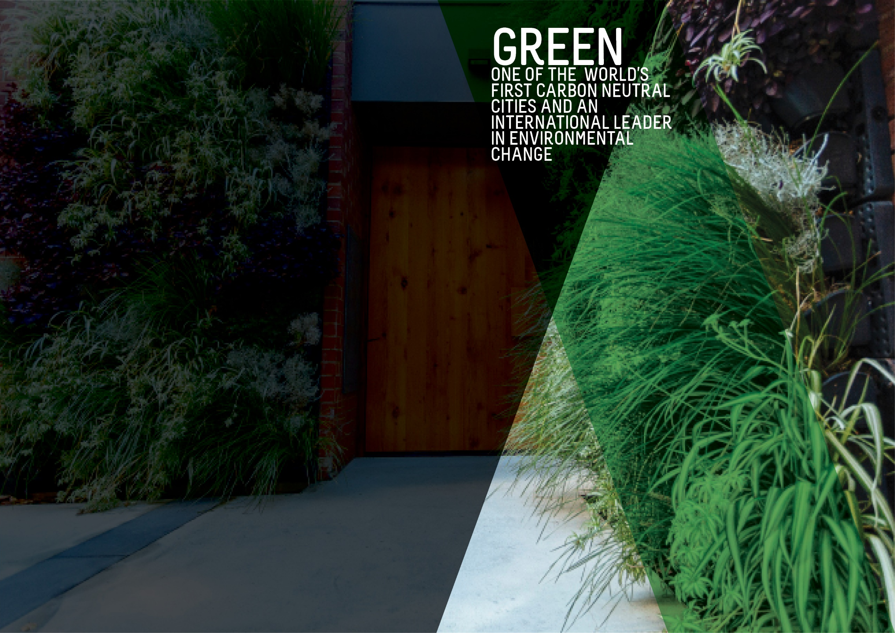
OBJECTIVES SUMMARY
The Green theme has five objectives. Updated data was not available for any of the objectives in the quarter.
ACTIONS SUMMARY
Of the 28 actions under Green, 24 were on track, three were on watch and one was complete at end Q2 2018/19.

24  ON TRACK |  | 3  ON WATCH |  | 0  OFF TRACK |  | 1  COMPLETE

OBJECTIVE | UPDATE | STATUS
CITY CARBON EMISSIONS WILL BE REDUCED BY 35% FROM THE 2006-07 BASELINE BY 2020 | The greenhouse gas emissions inventories for the City of Adelaide community were finalised for Financial Years 2016 and 2017 and updated for Financial Years 2007 (base year), 2014 and 2015 to ensure consistency with the latest calculation methodologies and were reported to Council. This has shown a 15% emissions reduction achieved between 2007 and 2017.  The overall reduction in emissions has been driven by a 37% reduction in stationary energy emissions, that is, emissions associated with the consumption of purchased electricity and natural gas. This demonstrates a decoupling of City of Adelaide community GHG emissions from the City of Adelaide Gross Regional Product which has increased by 35% over the same period. (Last updated Q3 2017/18)  Data source: City of Adelaide Community GHG Emissions Inventory | BASELINE:  1,148 kt CO2-e (2006-07)*  UPDATE ON OBJECTIVE:  976 CO2-e (2016-17)  NEXT UPDATE: TBA  DIRECTION OF CHANGE: favourable variance  * Revised from 1,175 kt CO2-e to ensure consistency with the latest calculation methodology
GREEN SPACE AND GREENERY IN THE BUILT-UP AREAS OF THE CITY WILL HAVE INCREASED BY 100,000 METRES BY 2020 | The baseline figure for green space and greenery comes from the Green Infrastructure Benchmark Data and Mapping project undertaken in 2015. Total green coverage is calculated by adding the total pervious area (total area minus total impervious area) to the area of tree canopy cover in built-up areas within the City. The built-up area of the City is the entirety of the City of Adelaide area minus the Park Lands  Data source: City of Adelaide | BASELINE:  1,241,777.11 (2015)  UPDATE ON OBJECTIVE:  Not available  NEXT UPDATE: 2019  DIRECTION OF CHANGE: not applicable
BY 2020, AQUATIC NATIVE PLANTS ON THE TORRENS LAKE FLOOR WILL HAVE INCREASED FROM ALMOST ZERO TO 7,500 SQUARE METRES | The re-introduction of aquatic native plants to the Torrens Lake floor is an ongoing process with results likely to take some time to achieve and quantify. Nursery propagation over winter has been successful. This year 7,125 aquatic plants have been planted in the Torrens Lake.  Data source: City of Adelaide | BASELINE:  Almost zero (2015)  UPDATE ON OBJECTIVE:  Not available  NEXT UPDATE: 2019  DIRECTION OF CHANGE: not applicable
A DETAILED MEASURE OF REDUCTION IN KERBSIDE AND GENERAL WASTE WILL HAVE BEEN DEVELOPED AND INFLUENCES OUR WORK | Council currently tracks kerbside waste and the proportion of recyclables. The scope of a suitable measure for kerbside and general waste reduction is being considered. Council has seen a small increase in waste going to landfill over the last 12 months because of providing waste services to an increasing number of medium to high density dwellings. | BASELINE:  To be determined  UPDATE ON OBJECTIVE:  Not available  NEXT UPDATE: TBA  DIRECTION OF CHANGE: not applicable
A COMPREHENSIVE INTEGRATED WATER MANAGEMENT MEASURE WILL HAVE BEEN DEVELOPED AND INFLUENCES OUR WORK | Council currently tracks mains water use, recycled water use and the cost of both. The recommendations from the review of the Biodiversity and Water Quality Action Plan have been finalised and will help to inform and develop the Integrated Water Management Plan and Integrated Water Management Measure. | BASELINE:  To be determined  UPDATE ON OBJECTIVE:  Not available  NEXT UPDATE: TBA  DIRECTION OF CHANGE: not applicable

ACTION | RESPONSIBLE OFFICER | UPDATE | STATUS
Achieve adoption of sustainable commercial practices through incentives, purchasing approaches, waste services and regulation (ANNUAL OBJECTIVE) | Associate Director, Sustainability | During this quarter, the Council Solutions Waste Project received final approval from the Australian Competition and Consumer Commission to go to market. Three tender packages were released to the market and submissions were received for all tenders. Evaluation of the received tender submissions has commenced and will conclude in Quarter Three. A report detailing recommendations will be delivered in Quarter Three. | on track
By 2020, Council’s New Year’s Event will send zero-waste to landfill and by 2018, clear guidelines will be developed for organisers of larger community events in Council-operated areas to achieve zero-waste and carbon neutrality | Associate Director, Sustainability | The Sustainable Events Guidelines were endorsed by Council on the 27th of November. | on track
By 2025, working with City waste collectors, all Council serviced premises will have their landfill, recycling and green waste collection measured and reported to Council, with the data to be available online to the premises' occupant | Associate Director, Public Realm | During this quarter, the Council Solutions Waste Project received final approval from the Australian Competition and Consumer Commission to go to market. Three tender packages were released to the market and submissions were received for all tenders.  Evaluation of the received tender submissions has commenced by the evaluation team and will conclude in Quarter Three. A report detailing recommendations will be delivered in Quarter Three. | on track
By December 2020, increase our efficient use of recycled water from the GAP scheme in Council-irrigated areas by 25% to an overall level of 80% | Associate Director, Infrastructure | The current proportion of GAP water utilisation is nearing the strategic target of 80% (78%). Further investigation is required to ascertain the cost benefits (if any) and future commitments to any additional increase in the use of GAP Water. | on track
By December 2017, complete a procurement plan for all Council vehicles to be low or zero emissions | Associate Director, Public Realm | No further updates as this action is complete. | COMPLETED
By June 2017, Council will have developed a Green City Plan detailing Council’s contribution to greening the city and showing activities with aligned annual targets, including an additional 1000 trees in the built-up areas of the city by June 2020 | Associate Director, Sustainability | Design projects to prioritise greening are in progress and on track to meet the approved target of 1,500 trees by June 2020. | ON track
By June 2019, our procurement practices will reasonably require the environmental track record and/or credentials of suppliers, and estimates of carbon emissions of products and services | Associate Director, Sustainability | The project plan for the Sustainable Procurement Initiative was finalised during Quarter Two and the procurement policy is currently being reviewed. It is anticipated that the revised policy will be brought to Council by June 2019 for consideration and endorsement. | on track
By June 2020, all Council-owned and maintained public lighting will be converted to LED lights and smart lighting wherever possible (ANNUAL OBJECTIVE) | Associate Director, Infrastructure | The LED program scope for 2018/19 is being delivered through the capital works program. The procurement exercise, SMART LED is currently out to market as the new strategic smart lighting program. The procurement phase has progressed with next stage being Request For Tenders (RFT) released to the market in Quarter Three. | on track
By June 2020, the energy requirement for all Council buildings will be sourced from low carbon or renewable energy sources | Associate Director, Infrastructure | The risks and opportunities associated with options for CoA's next electricity contract to be sourced from low carbon or renewable energy sources have been investigated and reported to Council at its meeting of 24 April 2018. Additional information was provided at a Council Committee meeting on 21 August 2018 by Minter Ellison.  During Quarter Two, work commenced on the Procurement Plan and the Expression of Interest documentation for the project. | on track
By the end of 2017, develop and implement a Waste, Recycling and Reuse approach for the City that reflects world’s best practice and the use of smart technology | Associate Director, Public Realm | During this quarter, the Council Solutions Waste Project received final approval from the Australian Competition and Consumer Commission to go to market. Three tender packages were released to the market and submissions were received for all tenders.  Evaluation of the received tender submissions has commenced by the evaluation team and will conclude in Quarter Three. A report detailing recommendations will be delivered in Quarter Three. | on track
Commit through to June 2020 to continue the Sustainable City Incentives Scheme, with annual reviews of incentive funding budget allocations | Associate Director, Infrastructure | A review of the Sustainability Incentive Scheme commenced during Quarter Two. It is anticipated that a revised Scheme will be brought to Council in later in the year for consideration and eventual adoption.  A total of $159,377 was provided in incentives, with a total project value of $412,209 during the quarter. 31 applications were approved and 36 applications were received. For every $1 in rebates approved, $6.90 was invested in sustainable technologies in Adelaide. The Scheme delivered 124 kW of solar PV; 14 kWh of energy storage; 138 LED lights; three energy monitoring systems; two hot water systems ; and four electric vehicle charging stations. | on track
Continue to work with the State Government and other councils to reduce stormwater and other pollutants into the Torrens River catchment | Associate Director, Infrastructure | CoA worked in partnership with other stakeholders, such as Adelaide and Mount Lofty Natural Resources Management, SA Water and the Environment Protection Authority to develop a water quality monitoring program for the River Torrens and Torrens Lake. Water quality data will continue to be used to inform management decisions. In particular, monitoring of blue green algae levels will inform the planning and delivery of amenity dilution flows to avoid blue green algae outbreaks during summer. | on track
Develop international trade, investment and tourism opportunities based on our green and clean reputation | Associate Director, Economic Development & Tourism | A draft Smart Green Economy Plan is being developed for consideration by Council in 2019. The report plan will assist in the capture of the economic, social and environmental benefits from a low carbon economy.  City of Adelaide is coordinating a social media campaign targeting current and prospective international students promoting the nature-based experiences and clean and green lifestyle in the city/ This campaign will occur in January/February to coincide with new student arrivals and the release of the 2019 International Student guide and a new CoA webpage designed specifically for students. | on watch
Enhance biodiversity in the Park Lands and strengthen the role of the Park Lands in achieving a carbon neutral City | Associate Director, Infrastructure | The Integrated Biodiversity Management Plan (IBMP), which includes six Key Biodiversity Areas and the location of a Community Education Hub for biodiversity, has been adopted by Council. The Biodiversity Monitoring Framework has been completed. The IBMP Governance Group has prioritised the 36 actions within the IBMP. Implementation of prioritised projects will commence in Quarter 3. | on track
Facilitate the reuse and recycling of equipment, consumables and materials used in festivals and events in the City | Associate Director, Customer | Work continues to determine how best to implement the recommendations from the review of event services including: waste, management of event spaces, utilities and infrastructure. A roadmap for Carbon Neutral Adelaide is being developed and the outcomes of the event services review will be integrated into this roadmap | on track
From 2016, collaborate with City-based businesses, interest groups and the education sector through a series of Lord Mayor summits and forums to build partnerships that promote environmental issues and broader innovations | Associate Director, Sustainability | On 20 November 2018, the City of Adelaide hosted a breakfast ‘Visions for a Carbon Neutral Adelaide’ with the Cooperative Research Centre for Low Carbon Living that was attended by 170 business people and researchers, including over 50 Carbon Neutral Adelaide Partners.  On 21 November 2018, Adelaide's high performing office spaces were celebrated at the 2018 SA CitySwitch Awards at the Adelaide Convention Centre. Award winners included the Commonwealth Bank of Australia, dsquared consulting, Cundall, Oxigen, Knight Frank and the tenants of Westpac House (91 King William). Invitations were sent out for the Feeling Hot Hot Hot event to be held on 6 February 2019 were sent out this quarter. | on track
From 2016, Council will commit ongoing funding for powerline undergrounding to assist with greening initiatives | Associate Director, Infrastructure | No update required as no activity planned for this quarter. | on track
Identify opportunities for building adaptation and re-use that supports heritage aspirations while reducing carbon emissions and waste | Associate Director, Sustainability | A Building Upgrade Finance Market Development Project Plan was agreed by the Department of Environment and Water (DEW - Grant Provider) and CoA with implementation commencing during this quarter. | on track
Improve energy performance and use of renewable energy in Council and privately-owned buildings, including consideration of solar heating, solar energy generation and battery storage (ANNUAL OBJECTIVE) | Associate Director, Sustainability | The preferred tenderers for the provision of solar PV on four City of Adelaide large electricity consuming sites were selected and engaged. The sites selected for solar PV systems were the Adelaide Aquatic Centre, Adelaide Town Hall, Pirie UPark and Topham UPark. A total of 840kW of solar PV capacity is proposed to be installed over the four sites. Detailed design and project planning commenced during the quarter. | on track
Improve the ecological value of watercourses and biodiversity in the Park Lands | Associate Director, Sustainability | Most of the woody weeds targeted for control for the Tainmuntilla Riparian Restoration project were removed. This included over 200 woody weeds, comprising olive trees, desert ash, swamp she-oak and pepper trees. Removal of woody weeds improves water quality and limits weed dispersal in the area and downstream. It also improves park safety and allows for new plantings, which will improve native biodiversity.  The next stage of the project has commenced including assessment and approvals to remove regulated trees and palms, and replacement species selection, taking into account provenance and climate change adaptation considerations. | on track
Partner with the State Government to implement a Carbon Neutral Adelaide Partnership Framework to pursue the shared aspiration for Adelaide to be the world’s first carbon neutral city | Associate Director, Sustainability | The 2018 financial year corporate greenhouse gas inventory was completed in Quarter Two, with the exception of the water data which is still outstanding from the provider. It is anticipated that this will be reported back to Council in Quarter Three  Adelaide's high performing office spaces were celebrated at the 2018 SA CitySwitch Awards at the Adelaide Convention Centre on 21 November 2018. The winners of the SA CitySwitch Awards for 2018 were:  - The Commonwealth Bank of Australia - Signatory of the Year greater than 2,000 sqm2;  - dsquared Consulting - Signatory of the Year less than 2,000 sqm2;  - Oxigen - New Signatory of the Year; and  - Knight Frank and the tenants of Westpac House - Partnership of the Year.  A video from the 2018 SA CitySwitch Awards and case studies on South Australian leaders are available on the CoA website. | on track
Provide a range of incentives for the use of electric-powered and low-emission vehicles within the City | Associate Director, Sustainability | Construction and commissioning of 40 on-street and off-street electric vehicle charging stations was completed in Quarter Two despite budget challenges. The charging system records utilisation at each location and reports are being developed to support ongoing monitoring and reporting.  Feedback was provided as part of the National Transport Commission consultation regarding changes to the Australian Road Rules about the challenges with nose-to-kerb parking and charging of electric vehicles. One electric vehicle charging infrastructure application for a fast charger was approved during the quarter. | on watch
Work with partners to reduce storm water run-off and pollution into the Torrens River through integrated catchment management and water sensitive urban design | Associate Director, Infrastructure | Projects have been identified for delivery in 2018/19 and 2019/20 and have been considered in the Integrated Business Plan program of works. | on track
Work with all City stakeholders to increase public and private greening with street trees, gardens, community gardens, green walls and roofs providing incentives where appropriate | Associate Director, Strategy & Design | Council continues to work with developers and other city stakeholders to prioritise public and private greening. Projects have been scoped to prioritise greening projects and design projects as part of the 2019-20 business planning process. Background investigations have been completed on the review of open space provisions with development with preparations underway to seek external input. | on track
Work with Federal and State governments to provide appropriate infrastructure and promote sustainable transport options, such as public transport, cycling and walking, to improve the experience of commuters and reduce transport-related carbon emissions | Associate Director, Strategy & Design | Council continues to work on providing appropriate infrastructure and promoting sustainable transport options. Detailed design is well underway for the next two sections of the North-South Bikeway comprising of new and upgraded shared use paths in Lefevre Park/Nantu Wama (Park 6) and Red Gum/Karrawirra (Park 12). Design, engagement and construction works will continue as a rolling program until the North-South Bikeway is complete. | on track
Work with local communities on public greening activities that will beautify streets and parks | Associate Director, Community & Culture | No update as no activity is planned for 2018-19 | on track
Work with partners to reduce mains water use through water sensitive urban design and increasing the use of recycled and reused water (ANNUAL OBJECTIVE) | Associate Director, Sustainability | The Integrated Water Management Measure is being progressed via the development of a Water Sensitive City Transition Plan. Work on the Plan will commence in following quarter in spite of an unsuccessful bid for funding from the Natural Resources South Australia Water Sustainability Grant program.  The ‘Turning Gray Street Green’ project was one of 17 successful projects to receive a Water Sustainability Grant and will commence in January 2018. The Water Inventory data is on track for reporting on Council's 2017/18 Water Profile late in Quarter Three. | on track
Work with private property owners and the State Government to embed better environmental performance into new and existing developments | Associate Director, Planning & Development | Advocacy to the Department of Planning, Transport & Infrastructure has occurred through the Planning, Development and Infrastructure discussion paper on Natural Resources and Environment. | on watch

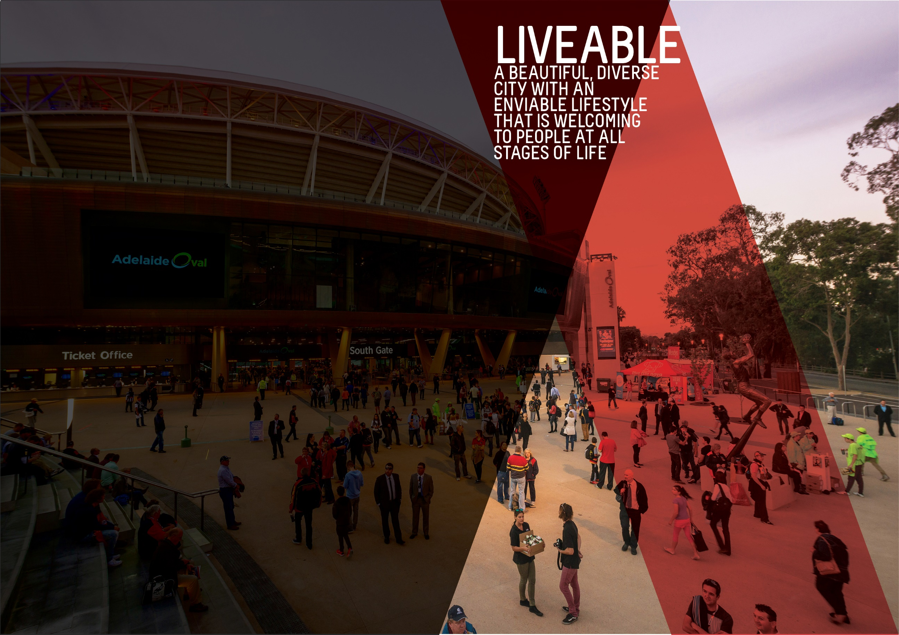

OBJECTIVES SUMMARY
The Liveable theme has three objectives. Updated data was not available for any of the objectives in the quarter.
ACTIONS SUMMARY
Of the 24 actions under Liveable, 22 were on track and two were complete at end Q2 2018/19.

22  ON TRACK |  | 0  ON WATCH |  | 0  OFF TRACK |  | 2  COMPLETE

OBJECTIVE | UPDATE | STATUS
THE NUMBER OF PEOPLE LIVING IN THE CITY WILL HAVE GROWN FROM 23,000 TO 28,000 BY 2020 | As at June 2017, the estimated resident population (ERP) of the city was 24,193 persons. This is 2.7% higher than the previous year and 7.3% higher than the baseline year in 2014. Population growth in the city continues to outpace the State's population growth. Between June 2016 and June 2017, population growth across South Australia increased by 0.6%.  Note: Previously, the ERP reported for the City of Adelaide for 2016-17 was 23,916, which was the preliminary figure released by the Australian Bureau of Statistics (ABS). The ABS have since revised their figures and released the final population estimates in August 2018. (Last updated Q1 2018-19)  Data source: ABS, ‘Regional Population Growth, Australia, 2016-17 (Cat. No. 3218.0) | BASELINE:  22,539 (ERP June 2014)  UPDATE ON OBJECTIVE:  24,193 (ERP June 2017)  NEXT UPDATE: Early 2019  DIRECTION OF CHANGE: favourable variance
ADELAIDE WILL BE LISTED IN THE TOP THREE MOST LIVEABLE CITIES IN THE WORLD BY 2020 | In 2018, Adelaide was ranked 10th in the Economist Intelligence Unit’s (EIU) Global Liveability rankings. This is the first time that Adelaide’s position has changed since 2012.  According to the latest EIU results, Adelaide’s overall rating score was 96.6 (a score of 100 is ideal) and has been unchanged from previous years. The reason for the change in ranking was due to other cities scoring higher and having a higher relative ranking compared to Adelaide. For example, Melbourne was ranked second for the first time in eight years despite an increase in its overall score from 97.4 to 98.4.  Of the five categories of liveability assessed by the EIU measure, Adelaide continued to score lowest (94.2/100) in the area of culture and environment, which includes factors such as sporting availability, cultural availability and food and drink, and its highest score (a perfect 100) in the education and healthcare categories. The EIU liveability rankings relate to the entirety of Adelaide and not specifically to the City of Adelaide. (Last updated Q1 2018/19)  Data source: Economist Intelligence Unit, Global Liveability Ranking 2017 | BASELINE:  Ranked 5th (2015)  UPDATE ON OBJECTIVE:  Ranked 10th (2018)  NEXT UPDATE: August 201  DIRECTION OF CHANGE: no change
CITY OF ADELAIDE RESIDENTS WILL HAVE WELLBEING ABOVE THE GLOBAL AVERAGE | During Quarter 2 2017/18, Council endorsed a change to the wellbeing objective from “A nation leading wellbeing and resilience measure will be applied and influences our work’ to ‘City of Adelaide residents will have wellbeing above global average”. This wording reflects the outcome of the PERMA+ survey undertaken with South Australian Health & Medical Research Institute (SAHMRI) in 2016 to contribute to the development of a baseline for residents’ wellbeing. It also reflects the focus of Council’s work to maintain resident wellbeing above the global average as articulated in the City of Adelaide’s Wellbeing Roadmap. | BASELINE:  PERMA+ score of 7.2 (September 2016)  UPDATE ON OBJECTIVE:  Not available  NEXT UPDATE: TBA  DIRECTION OF CHANGE: not applicable

ACTION | RESPONSIBLE OFFICER | UPDATE | STATUS
Advocate for an urban growth boundary that limits urban sprawl and promotes the City as the commercial, cultural, residential and social heart of metropolitan Adelaide | Associate Director, Planning and Development | No further updates required. This action is complete. The Urban Growth boundary commenced with enactment of the Planning, Development and Infrastructure Act 2016, as reflected in the Updated 30 Year Plan for Greater Adelaide. | completed
Advocate to the Federal and State governments for changes in housing taxation and levies to reduce the cost of housing, including an extension of the State government's 'Off-the-Plan Stamp Duty Concession’ for apartments | Associate Director, Economic Development & Tourism | Investigations are continuing in relation to Council's potential role(s) in advocating for affordable housing. The Strategic Property Review project has provided the opportunity for further input and investigations in relation to Council's existing assets and future projects. | on track
By 2017, endorse a Central Market Arcade redevelopment plan and commence works by 2020 | Associate Director, Property | A smooth transition process has been undertaken with Council working closely with the Central Market Arcade Traders Association to support centre marketing. All shop leases have been executed with ongoing centre management being undertaken Council.  Design development process is progressing seeking to resolve outstanding design matters particularly in relation to Council's Returnable Works (6,000 square metres NLA of retail, 260 car par spaces and loading). A retail scoping/ brief preparation underway to support design process.  A non-binding Heads of Agreement was prepared and negotiated with the respective proponents and has been executed by the parties with preparation of the Development Agreement underway. | on track
By June 2020, develop an Adelaide 2040 Plan to achieve long-term economic, environmental, social and cultural goals, incorporating a spatial and transport plan for the City and Park Lands | Associate Director, People & Governance | Previous work on Adelaide 2040 has been reviewed and consolidated for a future introduction to Council. | on track
Create world class infrastructure by adopting a three year rolling capital works program for the City and Park Lands to ensure all new and existing infrastructure are delivered and maintained to high quality standards, incorporating universal access, technology, heritage, arts and green elements. | Associate Director, Infrastructure | A three-year rolling Capital Works Program has been developed to inform the 2019/20 Integrated Business Planning process with a governance process is in place for the prioritisation of projects (renewal and new capital).  An Asset Management Transformation Project is also underway to develop improved asset management systems for the delivery of world class infrastructure. The Asset Policy and Infrastructure Strategy being developed as part of the project will incorporate best practices and processes to deliver efficient and value driven infrastructure for the community. | on track
Deliver Council’s core services efficiently and with brilliant customer service for a growing and increasingly diverse and multicultural community | Associate Director, People & Governance | To enhance the customer experience, the Customer Service Centre Concierge was put in place on a permanent basis. A customer satisfaction and feedback program were implemented for the Business Centre for the first time using shared measures across all permit functions. Four Service Reviews were completed in Quarter two identifying operating savings, reducing risk, increasing staff productivity, and ensuring equipment is in place to deliver the right outcomes for the community. | on track
Deliver sport and recreation activity hubs consistent with the Active City Strategy and Adelaide Park Lands Management Strategy | Associate Directory, Community & Culture | Work has continued on a range of community sports and recreation hubs including the final stages of a skate scoping study, sharing the findings of the Blue Gum Park / Kurangga (Park 20) BMX Tracks community engagement, progressing the business case for Josie Agius Park / Wikaparntu (Park 22) and undertaking community engagement on a draft concept plan for Golden Wattle Park / Mirnu Wirra (Park 21W). | on track
Develop and celebrate strong and resilient City communities that are welcoming and encourage people of all ages, cultures and means to participate in City life, including through volunteer opportunities (ANNUAL OBJECTIVE) | Associate Directory, Community & Culture | The Welcoming Cities Audit is underway and will determine CoA's current programs, support and responses to multicultural communities and people from refugee backgrounds. The audit will highlight opportunities for CoA to increase welcoming activity and work with communities to be a Welcoming City.  In partnership with the State Emergency Service, two Heatwave Awareness sessions were held in community locations. These sessions disseminated practical information to the local community on how to stay safe and well during heatwaves. A CoA branded business continuity template for small to medium enterprises (SMEs) was developed and disseminated by Enterprise Adelaide, encouraging SMEs to prepare for disruptions to their business.  Five events were held in community locations throughout National Nutrition Week in October. In partnership with Flinders University School of Nutrition and Dietetics, around 400 residents and visitors were provided with information about nutrition and the importance of eating more fruit and vegetables. Three workgroups were established to focus on three priority areas identified in the Wellbeing of Adelaide (WAY) Youth Community Plan; connecting young people to the community through participation, health literacy and healthy behaviours, and supported mental health.  As part of Mental Health Week 2018, two key neighbourhood events were delivered together with student accommodation providers to build social connections amongst their students and the local community. The second Adelaide Community Leaders in Sustainability program for 2018 was successfully delivered with another 20 participants graduating. This program delivered four community projects in the city based around the themes of energy, urban greening, climate resilience (Vulnerable Communities) and biodiversity.  The final meeting of the current Access and Inclusion Advisory Panel was held in November 2018. The draft (Disability) Access and Inclusion Plan 2019-2022 was presented to the Panel at this time. The draft had been consulted on with the community during September to October 2018.  13 Community Development Grant enquiries were received during this quarter with two applications assessed - one quick response and one minor. The quick response grant was approved for a total of $896. A number of projects funded in Quarter One were delivered during Quarter Two including ‘Street Guitars’, a program run by Carrington Cottages. This program provides opportunities for men who are at risk of homelessness to play guitars together to build confidence and establish pathways for reconnection to the local community.  135 city residents received Commonwealth Home Support Programme services this quarter with social programs focussing on nutrition and healthy eating. The North Adelaide Age Friendly Business Project commenced with 19 participating businesses. Sixteen older community members were involved in the project as mystery shoppers to assess the age friendliness of participating businesses.  Partnering with the Art Gallery of South Australia, 12 World Tea Gathering performances were presented in City Library spaces and the Francis Street laneway. Partnering with Guildhouse, local artist Kaspar Schmidt Mumm delivered a series of community-based workshops as an extension of his ArtWorks residency at the Minor Works building. City Library hosted ‘People, Celebrating People’, a major exhibition presented in partnership with City Archives and local contemporary artists with local youth choir Aurora performing at the opening event. Partnering with the University of Adelaide, two successful Philosophy Café events were presented, ‘Are You What You Eat?’ Food Ethics & Food Citizenship and Computational Philosophy. CoA also partnered with the University of South Australia to present the ‘What’s Art Got to Do with It?’ Program resulting in the first Arts Café event, ‘Wine, Art and Tourism: South Australia’s Unique Cube’.  Library Out & About community engagements this quarter included visits to Music in the Square, Adelaide Town Hall Open Day, Festival of Now, Homeless Connect Expo, OzAsia Festival and the Feast Festival Picnic with positive feedback received. The Library partnered with YA Jungle delivering NaNoWriMo (National Novel Writer's Month) workshops, inspiring budding writers.  The National Museum of Australia presented two live and interactive video tours ‘Black Mist Burnt Country’ and ‘Heroic Animals in Australia’. Smart Spaces delivered a program of group workshops and one-on-one sessions in the Digital Hub, Media and Innovation Labs, and Digital Communities in the ACH Tech Savvy Series. Roaming Robots and Virtual library programming continued to engage, surprise and delight the community during the quarter. | on track
Encourage City living by understanding the demand drivers and developing a distinctive City living promotion campaign that builds on the Already Home campaign | Associate Director, Economic Development | The QF1 budget bid of $80,000 for the Residential Growth Action Plan (including the City Living Campaign) was approved in December. A brief for the City Living Prospectus (including defined target markets) has been workshopped and content drafting and photography will follow. Channels to market have been identified and a database is being populated. Meetings with key external stakeholders having taken place to test the concept and feedback taken on board. A submission was prepared for the SA Economic and Finance Committee’s Inquiry into “The Economic Contribution of Migration to South Australia. | on track
Encourage growth in the full range of residential property development in a mixed-use environment in a manner that respects the human scale and different characters of districts in the City | Associate Director, Economic Development | The apartment development database is in the process of being updated ahead of the end of year Apartment Market report being prepared in 2018/19 Quarter Three. | on track
Encourage the State Government to improve public transport to promote greater patronage, including continued investment and expansion of the free City Connector Services | Associate Director, Strategy & Design | Council are continuing to liaise with the State Government for a roll-out of an expanded audio and visual display system to the City Connector bus fleet. Council installed the final CoA digital bus stop on King William Road near North Terrace during the quarter. An additional three bus shelters are proposed to be installed at free City Connector stops in 2019. | on track
Enhance the role of the Park Lands in increasing levels of physical activity and wellbeing through formal and informal sport and recreation opportunities | Associate Director, Community & Culture | Due to caretaker provisions and no rounds of funding being called in this quarter, only one Recreation and Sports Grant was awarded. Promotion of the grants program commenced in the latter part of this quarter including the planning of a grants workshop scheduled for late January 2019.  At the end of Quarter Two, total spend on the Adelaide Park Lands Trail is $190,000 of $2.1m, noting that all works are either contracted, or about to be tendered and are on track for delivery by June 2019.  Council previously voted to defer release of the Golf Course Master Plan until a Cultural Heritage Assessment (incorporating Indigenous and European history) could be completed along with further Adelaide Park Lands Authority consultation. A Cultural Heritage Assessment is currently underway and when completed, will inform the Master Plan document to be presented to Council and Adelaide Park Lands Authority for discussion. | on track
Explore opportunities in Council’s current property holdings and pursue strategic opportunities to lead or partner in future property developments | Associate Director, Property | CoA is currently finalising a Strategic Property Review to present to Elected Members the opportunities linked to council’s property assets. The review will look at acquisition and disposal of assets, non-performing assets, partnering opportunities and future strategic purchases and land banking. | on track
In partnership with the State Government, explore the possibility of redeveloping Currie-Grenfell streets as a public transport boulevard to cater for increased demand | Associate Director, Strategy & Design | A report and concept plan options for the Currie-Grenfell transport boulevard has been developed. These concepts will enable Council to further progress options for redevelopment of the corridor with the State Government. | on track
Increase participation by the broadest range of residents in the community life of their neighbourhood | Associate Director, Community & Culture | In November, the Box Factory Community Centre delivered the ‘Unwrapped: Mural Party’, which was the culmination of community workshops and the final delivery of the public art mural by Sarah Boese in the Box Factory Community Centre’s courtyard. This community event attracted 110 community members and consisted of live music, art and performance.  The three community centres were also successful in recruiting 31 residential streets across the city and North Adelaide to get local residents to put up Christmas bows to enhance their streets during the festive season. The South West Community Centre supported a local resident to run a successful 3D printing workshop teaching other residents to create and print their 3D designs. The North Adelaide Community Centre supported two residents to deliver a large scale exhibition commemorating the Centenary of Armistice 1918-2018, featuring war artists, residents’ relatives, Adelaide war recruitment propaganda, Aboriginal soldiers, and women in war. Both these community-led activities were well received by the local community. | on track
Plan and deliver priority walking and cycling routes throughout and beyond the City and Park Lands, including the provision of East-West and North-South cycleways and connections | Associate Director, Strategy & Design | Detailed design is well underway for the next two sections of the North-South Bikeway including new and upgraded shared use paths in Lefevre Park/Nantu Wama (Park 6) and Red Gum Park/Karrawirra (Park 12) in North Adelaide. Design, engagement and construction works will continue as a rolling program until the North-South Bikeway is complete.  The construction of the City West Quietway and road resurfacing in Blenheim Street and Lowe Street has been completed. Work is currently being progressed on the designs for Gray Street (Currie Street to Waymouth Street). | on track
Plan and seek partnerships for major City infrastructure projects, including cycling corridors, major transport routes and laneways | Associate Director, Strategy & Design | Actions under the Smart Move Implementation Plan continue to be delivered during this quarter.  A survey of over 450 pedestrians was undertaken to inform the Pedestrian Safety and Traffic Signals trial on Hutt and O'Connell streets. The data is currently being finalised to inform projects such as the city-wide speed limit review and city-wide crash review.  Timed motorcycle parking is being trialled at 11 motorcycle parking spaces on Kintore Ave and Hindmarsh Square. Other projects include the annual City of Adelaide pedestrian and bike cordon count with the Department of Transport, Planning and Infrastructure, and the South Ward Local Area Traffic and Parking Management | on track
Promote and protect Adelaide’s built character and heritage through our operations, incentives, policies and direct investment, while working with and advocating to Federal and State governments for an increase in City buildings protected under State or Local Heritage regulations (ANNUAL OBJECTIVE) | Associate Director, Planning & Development  CHECK WITH AMY | A number of activities were undertaken in Quarter 2 to promote and protect Adelaide’s built character heritage. Work has continued on the Heritage Promotion Program as well as on ascertaining customer satisfaction for the Heritage Incentive Scheme. A sponsorship agreement was confirmed between History SA and the City of Adelaide for the South Australian History Festival. | on track
Support social entrepreneurs to develop business models that have a positive impact on the City’s wellbeing and resilience | Associate Director, Community & Culture | There is no further activity planned for this Action and there will be no further updates provided for the remainder of the City of Adelaide 2016-2020 Strategic Plan.  Related activity is occurring and will be reported against the Action “Attract and support artists and cultural entrepreneurs to develop commercial opportunities” under the Creative Theme. | completed
Work with neighbouring councils and the State Government to enhance the facilities, attractions, landscapes and movement networks in the Park Lands to meet the needs and expectations of growing high-density communities living in and near the City (ANNUAL OBJECTIVE) | Associate Director, Strategy & Design | The City of Adelaide continues to work with the City of Prospect to refine the scope and develop a detailed design brief for the enhancement of Denise Norton Park/Pardipardinyilla (Park 2) and Yam Daisy Park/Kantarilla (Park 3) on either side of Prospect Road. | on track
Work with the community and other stakeholders through a range of initiatives to activate key areas to enable people to use the City safely and seek to reduce crime | Associate Director, Community & Culture | CoA worked with residents of the Playford Estate in Old Treasury Lane, Housing SA and SAPOL to hold a successful community BBQ with 28 attendees in response to reported safety issues in the Housing SA estate. Two residents received community spirit awards presented by Councillor Simms. A resident-led Dotmocracy exercise was conducted to improve community connection and perceptions of safety with 21 people participating. | on track
Work with the State and Federal governments and other councils through the Mayors for AdeLINK advocacy group to engage with local communities to progress an integrated light rail network across the City’s key precincts, with key connections to inner city suburbs | Associate Director, Strategy & Design | Council continues to work with the State Government on the upgrade of the City South tram stop on King William Street. Council will also continue to lobby for expanding the AdeLink tram network in the City and North Adelaide with the State Government following the completion of the North Terrace light rail extension. | on track
Work with the State Government to address housing affordability, including diversity of dwelling stock, and deliver a range of initiatives such as adaptive building re-use and new building technologies | Associate Director, Economic Development & Tourism | Investigations on housing affordability and diversity of dwelling stock are occurring in association with Council's Strategic Property Review. | on track
Work with the State Government, community leaders and community organisations to support vulnerable members of the community (ANNUAL OBJECTIVE) | Associate Director, Community & Culture | Activity for Quarter Two included the Lord Mayor's annual Christmas Lunch in December with potential members for a Business Alliance in aid of the Adelaide Zero Project. The aim of this lunch was to increase business support of the project and raise funds. The Adelaide Zero Project continues to make progress in housing and supporting rough sleepers across the city, working with a broad range of stakeholders to identify innovative solutions to homelessness in Adelaide.  Council delivered the Homeless and Vulnerable People Project by ensuring city-based social services are made aware of people at risk/ experiencing homelessness in the public realm and working with them to achieve the best outcome. In November, CoA representatives attended a forum hosted by the South Australian Housing Authority to consult on the development of the South Australian Housing and Homelessness Strategy. This Strategy is due to be completed in July 2019 and CoA will continue to take up opportunities to be involved in the process. | on track

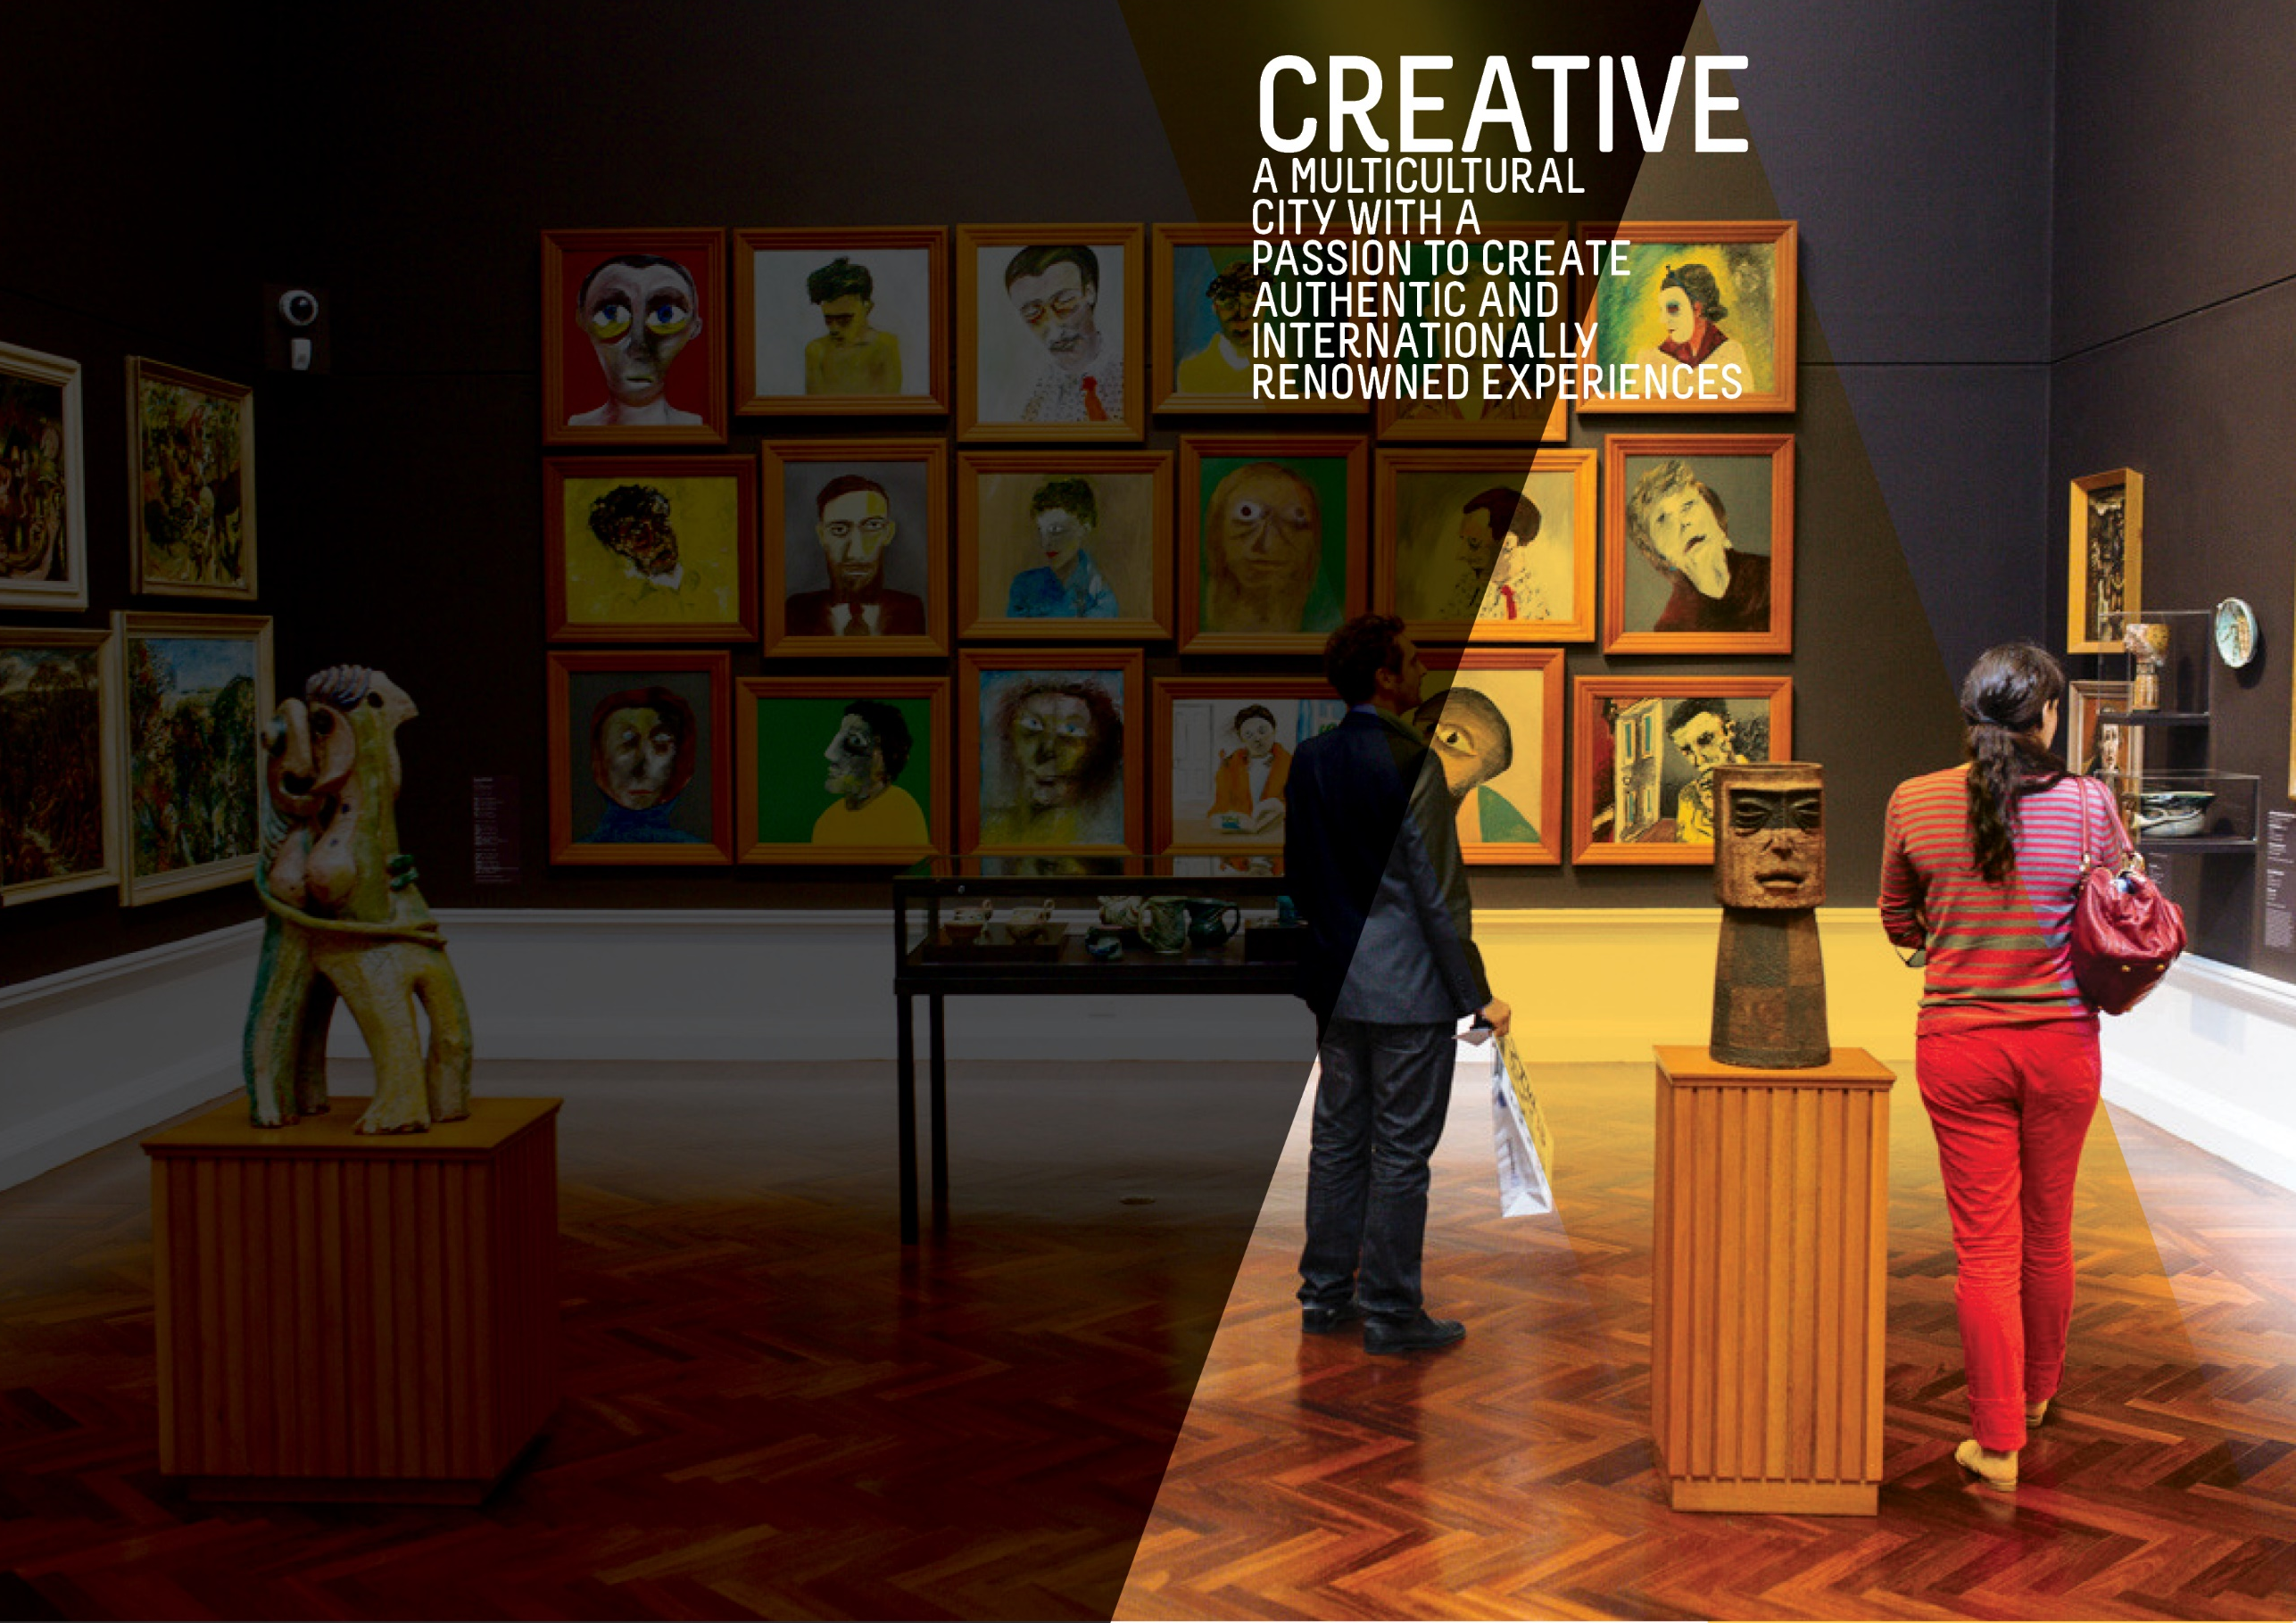
OBJECTIVES SUMMARY
The Creative theme has four objectives. Updated data was available for one of the objectives in the quarter.
ACTIONS SUMMARY
Of the 32 actions under Creative, 29 were on track and three were complete at end Q2 2018/19.

29  ON TRACK |  | 0  ON WATCH |  | 0  OFF TRACK |  | 3  COMPLETE

OBJECTIVE | UPDATE | STATUS
ATTENDANCE AT FESTIVALS AND EVENTS IN THE CITY AND PARK LANDS WILL HAVE GROWN BY 5% BY 2020 | According to the latest event attendance figures available, there were a total of 6.11 million attendances at festivals and events in the city in 2017-18 (averaged over two years). This represents a growth of 8.7% or 299,000 attendances from the baseline.  This increase has been driven by greater attendance at a number of key events in 2017-18 including OzAsia Festival, South Australia Living Artists Festival (SALA) and the Adelaide 500. Adelaide Oval attendance figures for November 2017 to October 2018 also reached high of 1.7 million attendances while the Adelaide Fringe Festival continues to break previous records and remains as the largest Fringe Festival in the world after Edinburgh Festival Fringe. (Last updated Q1 2018/19)  Data source: City of Adelaide | BASELINE:  5.62 million attendances  (average of 2013-14 and 2014-15)  UPDATE ON OBJECTIVE:  6.11 million attendances  (average of 2016-17 and 2017-18)  NEXT UPDATE: Late 2019  DIRECTION OF CHANGE: favourable variance
A DETAILED MEASURE OF THE NUMBER OF PEOPLE CREATING AND ACTIVELY PARTICIPATING IN ARTS AND CULTURAL ACTIVITIES WILL HAVE BEEN DEVELOPED AND INFLUENCES OUR WORK | This measure captures the level of active participation in arts and cultural activities in the city. The data is collected through the City of Adelaide's annual City User Profile (CUP) Survey, which asks city users (people who are in the City on the day of the survey) whether they had actively participated in any of a specified range of activities in the city in the preceding 12 months. These activities include creating music, participating in a theatre/ dance/ performance/event, parade or show, visual arts and craft and creative writing and is based on the Australian Council of Arts definition of active participation.  The results from the 2018 CUP Survey found that the number of city users who actively participated in arts and cultural activities was 15%. This is lower than the level of participation recorded in 2017 (18%) and is also marginally lower than the baseline level of 16% in 2016. (Last updated Q4 2017/18)  Data source: City of Adelaide City User Profile (CUP) Survey 2018 | BASELINE:  16% (2016)  UPDATE ON OBJECTIVE:  15% (2018)  NEXT UPDATE: August 2019  DIRECTION OF CHANGE: unfavourable variance
BED NIGHTS SPENT IN ADELAIDE BY INTERNATIONAL AND DOMESTIC VISITORS WILL HAVE GROWN FROM 8.1 MILLION TO 9 MILLION BY 2020 | In the year to June 2018, the number of international and domestic visitor nights spent in the city reached 9.55 million and is 7.6% higher than the same time last year. The number of visitor nights to the city has increased from the baseline figure of 8.1 million and continues to exceed the target of 9 million visitor nights.  The growth over the year continues to be driven by a higher number of domestic visitor nights, which increased by 15.8%, rising from 4.5 million in the year to June 2017 to 5.1 million by June 2018. In comparison, international visitor nights fell slightly by 0.8% during the same period.  Data source: Tourism Research Australia, unpublished data | BASELINE:  8.059 million (June 2014)  UPDATE ON OBJECTIVE:  9.55 million (year to June 2018)  NEXT UPDATE: April 2019  DIRECTION OF CHANGE: favourable variance
PEOPLE WHO SAY THE CITY HAS GREAT PLACES TO ENJOY EVENTS, ACTIVITIES, ART AND CULTURE WILL HAVE GROWN FROM 8.4 TO 9 OUT OF 10 BY 2020 | The results of the 2018 City User Profile (CUP) survey show that the rating out of ten for agreement with this statement is 8.3. While this is marginally lower than the 8.4 recorded in 2017, it represents a positive movement from the baseline figure of 8.2 recorded in 2016. (Last updated Q4 2017/18)  Data source: City of Adelaide City User Profile (CUP) Survey 2018 | BASELINE:  8.4/10 (2015)  UPDATE ON OBJECTIVE:  8.3/10 (2018)  NEXT UPDATE: August 2019  DIRECTION OF CHANGE: No change
THE NUMBER OF PEOPLE THAT ARE VISITING THE CITY EACH DAY FOR SHOPPING, LEISURE OR ENTERTAINMENT WILL HAVE GROWN FROM 111,000 TO 117,000 BY 2020 | The number of people visiting the City each day for these purposes continues to increase and has exceeded the target of 117,000 by 2020. In 2018, there were an estimated 156,900 people in the City for shopping, leisure or entertainment on an average weekday. (Last updated Q4 2017/18)  Data source: City of Adelaide | BASELINE:  111,141 (2014)  UPDATE ON OBJECTIVE:  156,900 (2017)  NEXT UPDATE: August 2019  DIRECTION OF CHANGE: Favourable

ACTION | RESPONSIBLE OFFICER | UPDATE | STATUS
Advocate for the interstate rail station to be relocated back to the Adelaide Railway Station to capitalise on the iconic Indian Pacific, Ghan and Overland rail services | Associate Director, Strategy & Design | Liaison continues with the State Government on the return of interstate train services to Adelaide Railway Station. Discussions with the new State Government are ongoing regarding projects within the city and Park Lands. | on track
Attract and support artists and cultural entrepreneurs to develop commercial opportunities | Associate Director, Community & Culture | The Business of Being Creative (TBOBC) review was completed, and planning for the 2018/19 program commenced.  Four activations were delivered on 88 O’Connell Street site, including Pop-up Nature Maze, Twilight Market, Christmas decorations program and a precinct-led Market and Movie evening. All activations were well attended and received fantastic feedback from the community and precinct association. A post-event summary for each activation will be included in the report being prepared in Quarter Three.  Splash Adelaide is currently under review and has been on hold this financial year. A revised approach for the Splash Adelaide program is currently being developed. | on track
Attract people from around the world, especially from China and India, to spend more time and experience more hospitality activities in the City | Associate Director, Economic Development and Tourism | CoA representatives participated in a State Government organised inbound delegation of Indian businesses. Indian business delegates were in Adelaide to scope future investment opportunities. Among the delegates were representatives from HCL Technologies, an Indian owned international business that has recently opened an office 80 Grenfell Street.  A 12-month marketing plan for the City of Adelaide WeChat account was developed in collaboration with an external WeChat digital agency. At the end of December 2018, the CoA WeChat account had 710 subscribers since going live in July 2018. A modest target of 1,000 subscribers by 2020 was set and will be exceeded within a few months. | on track
By 2020, develop build and upgrade infrastructure that supports events and is sensitive to the environment within key event spaces in the city and Park Lands (ANNUAL OBJECTIVE) | Associate Director, Customer | During this quarter, costings were sought to upgrade event infrastructure in Rundle Park/Kadlitpina (Park 13) and Rymill Park/Murlawirrapurka (Park 14). Based on these costings it has been determined that over 2018/2019, the planning for upgrading of Rundle Park will be prioritised with detailed design work to begin in Quarter Three. A variety of options to improve the current remediation process for events in the Park Lands have been identified. Consultation with event organisers regarding testing some of these options for the upcoming Festival season has commenced. | on track
By December 2020, Council will install a network of NBN-enabled interactive wayfinding stations to build on the current roll out | Associate Director, Information Management | Evaluations on all Expression of Interest submissions received for the Digital Customer Experience Project are being progressed. | on track
By June 2017, develop an Arts and Culture Strategy | Associate Director, Community & Culture | No further updates as this Action is complete. | completed
Complete the Rundle Mall Master Plan, including Gawler Place, to link major City attractions | Associate Director, Strategy & Design | Council has approved an upgrade design for Gawler Place between North Terrace and Grenfell Street. Detailed planning is now underway for delivery and completes the overall intent of the Rundle Mall Master Plan. | on track
Consider policy de-regulation to allow more interesting temporary opportunities in private buildings | Associate Director, Planning & Development | Council provided a written submission to the Department of Planning Transport Infrastructure on the draft Land Use Definitions discussion paper. Council also used this opportunity to raise the issue relating to "temporary change of land use" and how the development legislation could potentially allow more interesting temporary opportunities in private buildings. | on track
Identify opportunities to use specialised lighting to showcase the City’s unique attractions, character and heritage | Associate Director, Strategy & Design | A number of decorative lighting projects are underway in Quarter Two including the Lighting Master Plan, and specific lighting projects for Paxton's Walk, Frome Street, and Ebenezer Ave/Vardon Avenue. These projects will continue to support the evening economy and create an attractive night time destination | on track
Increase public art and cultural expression in private development by using planning levers and requirements | Associate Director, Community & Culture | No update required as no activity was planned for the quarter. | on track
Partner with cultural institutions to increase visitations in the City and Park Lands | Associate Director, Community & Culture | A new strategic partnership was developed with Access 2 Arts to provide tailored workshops for the deaf and disabled creative community in the City Library along with a creative residency and professional development workshops to guide the wider community about accessibility in events. A second year of partnership was confirmed with the Helpmann Academy to support the development of their 2018 Graduate Exhibition and to deliver the City of Adelaide acquisitive prize. A second expanded program for Artworks, creative activation of the Minor Works Building was developed and will be delivered throughout January – August 2019 in partnership with Guildhouse. | on track
Promote and showcase multiculturalism and Aboriginal culture and support local organisations to express this heritage | Associate Director, Community & Culture | CoA coordinated engagement of families in the Park Lands Naming launches for Aunty Josie Agius / Wikaparntu Wirra (Park 22) and Aunty Gladys Elphick / Narnungga (Park 25) events. No Reconciliation Committee Meeting or RAPT meeting held during this quarter due to timing of end of Council term. A combined update will be provided in report to first Reconciliation Committee meeting of new term on 27 February 2019. | on track
Promote our UNESCO Live Music accreditation to attract more opportunities for new live music venues (ANNUAL OBJECTIVE) | Associate Director, Community & Culture | Adelaide’s UNESCO City of Music status was promoted through Adelaide Living article ‘Festive Sounds’ wile Music in the Square Spring Sessions (1,200 followers) and Summer Sessions (700 followers) Facebook pages promoted the City of Music status. Council engaged a researcher to explore international best practice Cities of Music for a Council report early in 2019. Part A research on global case studies was completed in December.  Music in the Square October and November events were delivered by 48 participants including musicians to an audience of around 900 people. Council also facilitated the City of Adelaide Pipe Band to perform at the City to Bay Fun Run and the Adelaide Town Hall Open Day. A Pipe Organ Recital Concert was co-delivered in Adelaide Town Hall in December to an audience of 800. | on track
Provide support to key festivals and organisations to assist them in offering events and activities that attract visitors to the City | Associate Director, Economic Development & Tourism | Five agreements/addendums were executed during this quarter. Three of these agreements were unchanged from 2017-18. Fourteen agreements have been executed year to date and equates to 58% of the total number of contracts managed.  Five agreements were also progressed during the quarter but not finalised. Benefit delivery and leveraging activities were ongoing. $770,000 in funding was distributed to applicants during the quarter ($950,000 year to date) and equates to 56% of the funding component of the sponsorship budget year to date.  Festivals Adelaide funding was distributed this quarter and the Festivals Adelaide 2018/19 Quarter One report was presented at the review meeting held in December. | on track
Pursue completion of the North Terrace Boulevard, focusing on the evolving health and biomedical precinct and the Riverbank precinct | Associate Director, Design & Strategy | Council continued discussions with the State Government and other key stakeholders on the development of North Terrace. The Draft North Terrace West Concept Plan has been finalised and will be used to explore staging and funding partners. | on track
Streamline Council processes for events to be hosted in the City and better enable City businesses to benefit from these events | Associate Director, Customer | Planning has commenced for the second round of the multi-year event licence opportunities in March 2019. This timing aligns with the opening of Council's Sponsorship program. This quarter also saw Phase One of Council's new online event booking system implemented. | on track
Support businesses, community groups and individuals to grow their contribution to the creative, cultural and artistic life of the City | Associate Director, Community & Culture | Round Two of the Arts and Cultural Grants program for 2018-19 featuring Public Art, Community Programs and Events and Live Music Enterprise Categories was administered during Quarter Two. 37 applications were received with 12 grant recommendations totalling $73,000.  The Terrance Plowright project continued in collaboration with the Art Gallery of South Australia. The Art Gallery is working with engineers and a donor on the next stages in respect to the outcomes of engineering review.  The development and prototyping of the accompanying artworks to the AED (Automated External Defibrillators) project was completed and fabrication commenced. Advice was provided to two external parties on two proposed memorials, ‘The Spirit of Woman’ not-for-profit committee is preparing a proposal for a memorial (A Place of Courage) in recognition of the impact of domestic violence, and the Vietnamese Boat Peoples Monument Association is preparing a proposal to recognise the contribution of Vietnamese refugees to South Australia.  The Emerging Curator partnership with the Helpmann Academy was launched with three exhibitions including ‘Stitching Yarns’ curated by Ursula Halpin and ‘Ones and Zeroes’ curated by Mia van den Bos. Additionally, a series of workshops are underway to activate the Art POD allowing visitors to engage with exhibiting artists to create artwork and exchange stories.  Council attended the National Local Government Cultural Forum where it was agreed that the National Data Collection Trial would continue. A trial to embed cultural outcome measures for the exhibition ‘People Celebrating People’ was completed and preparation was undertaken to include cultural outcomes measures in the survey of all library programs at the start of Quarter Three. | on track
Support the Adelaide Convention Bureau financially and in-kind to encourage longer stays and add value to the visitor experience, especially in areas that support Council’s strategic agenda | Associate Director, Economic Development & Tourism | CoA hosted a VIP lunch with the Lord Mayor as part of a site inspection for a prospective 6,000 strong incentive group in 2020 from China. In support of this inspection, Council lit up the Adelaide Town Hall and city fountains in the company’s colours during their stay and assisted with permits for fireworks on the Riverbank. Personalised welcome letters from the CEO were also provided to the VIP group.  Council also confirmed a support package for another incentive group bid for 8,000 people in 2020. These incentive group support packages can include; street activations, city dressing and promotions, business engagement and access to the Lord Mayor for VIP functions at the Adelaide Town Hall and as a guest speaker. | on track
Surprise, delight and attract people by continuing to encourage and support dynamic and changing urban public spaces, heritage, art, laneways, streets, facilities and activities (ANNUAL OBJECTIVE) | Associate Director, Strategy & Design | Council's New Year's Eve event was successfully delivered this quarter. The planning for this event involved the briefing and coordination of a large number of stakeholders such as emergency services, waste contractors, vendors, security, the public art contractor and the volunteers.  Christmas in the City was delivered with a Lifesize Rudolf the Reindeer and Santa’s Sleigh in Victoria Square. This provided an amazing photo opportunity for thousands of people attending the Victoria Square Twinkling Lights, Festive Nights activation.  Work on the Elder Park Master Plan is well underway with the completion of the Site Analysis and Due Diligence. The opportunities and constraints of the site are currently being explore and external stakeholder engagement is planned.  The Bentham Street survey works for the Market to Riverbank link have been completed. Early works are underway and continuing to co-ordinate the streetscape design with stakeholder requirements for third party infrastructure in the street. Artists have been selected and engaged to commence development of concepts for public art component in Bentham Street. | on track
Upgrade and improve amenity to create a higher quality visitor and trader experience by implementing the Our Market District Plan | Associate Director, Economic Development & Tourism | The Market District Reference Group and representatives from neighbouring Precinct Groups, Central Market Arcade, Chinatown, Uniting Communities, Hilton Hotel and the DPTI met twice to provide input into the Chinatown reinvigoration concept plans and receive updates on the Central Market Arcade project. The Market District Reference Group continues to oversee the planning and delivery of the upgrade and amenity improvement to create a higher quality visitor and trader experience by implementing the Our Market District Plan. | on track
Work in partnership with key stakeholders to attract a winter music festival by June 2018. | Associate Director, Community & Culture | Council supported 13 unique curated events for Umbrella Winter City Sounds including ‘Scouted’ across 4 venues, ‘Sconefest’, ‘Opening Night Street Party’, ‘Americanathon’ and ‘Who Run the World’ featuring a total of 87 artists in 56 City venues including new music spaces such as carparks, city fashion businesses and a library. Across the two-week festival, 83 city venues hosted an Umbrella event, with an average of 100 participants at each event. Umbrella engaged 1,800 musicians and had 45,000 overall attendances. Community Feedback highlighted that ‘Umbrella Festival is great at keeping Adelaide active in the cooler months’ and 74% of Music SA survey respondents are likely to attend Umbrella next year. As Council has successfully attracted a winter music festival, this action is now complete with no further updates for the remainder of the Strategic Plan. | completed
Work with businesses and other partners to bring creativity and smart technology into the everyday experience of our City | Associate Director, Information Management | A network of 60 sensors have been installed around the city to better understand how people move in and around our city. This network will allow a greater and more in depth understanding of city usage and pedestrian movements to inform asset planning from Council’s perspective, and business and event planning from an internal and external perspective. Entrepreneurs and city businesses have access to high value data from a city-wide sensor network that provides pedestrian movement data.  The City of Adelaide has installed a number of solar-powered ‘Smart Bins’ and ‘Smart Bin Sensors’ in key areas of the city to help keep our streets cleaner and more attractive. By using smart waste technology, the bins can be emptied on an as-needed basis, preventing rubbish from overflowing and spilling onto the footpath and thus ensuring cleaner and more hygienic streets and public spaces. Waste collection can be inefficient when using static routes and schedules as some bins are nearly empty, making waste collection unnecessary while other bins are overflowing with waste causing unnecessary clean-up costs.  The Smart Environment Monitor project will collect a variety of information, which will be made available to the public via open data. The sensors will monitor a range of environmental factors such as carbon dioxide, dust and temperature. This data can then be used to create innovative solutions to improve the experience of the city. The first set of five sensors have already been deployed around the city with data to be published soon.  This Action is considered complete. | completed
Work with existing festivals and events to increase the number and diversity of audiences and visitors | Associate Director, Economic Development & Tourism | CoA led and supported a variety of initiatives including the Spring ‘umbrella’ campaign that, in part, promoted events and festivals in the CBD and supported the execution of the New Year Eve event. The 2018 Christmas campaign has been more vibrant and visible across the city than ever before, especially at its home-base at Victoria Square. | on track
Work with neighbouring councils and the State Government in funding and governance to enhance the role of the Park Lands as a key City asset in supporting artistic and cultural activities (ANNUAL OBJECTIVE) | Associate Director, Strategy & Design | CoA continued to work with the City of Prospect and the State Government on a detailed design brief for the upgrade of Denise Norton /Pardipardinyilla (Park 2) and Yam Daisy Park/Kantarilla (Park 3) on either side of Prospect Road. Council has also worked with the State Government regarding the integration of the Botanic High School into its Park Lands setting east of Frome Road, and with the Kaurna community regarding the launch of the re-named Josie Agius Park / Wikaparntu Wirra (Park 22).  The Gawler Place Public Art Program continues to progress with the engagement of a curator to work with Council on various projects. Other projects progressed include the Market 2 Riverbank public art component, Cultural Marker Stage 2 upgrade, and the provision of asset management support to maintain existing artworks located in Hindley street, Leigh Street and Rundle Street during service works. | on track
Work with partners and key stakeholders to develop Adelaide as the premier international arts market, especially within the Asian region | Associate Director, Economic Development & Tourism | Festivals Adelaide continues to work with South Australian Tourism Commission for exposure of "Adelaide, Australia's best Festival City" in the UK. Festivals Adelaide visited Montreal and met with representatives of key festival cities including Edinburgh, Montreal, Singapore, Krakow and Austin, Texas. The following areas of interest for shared knowledge, best practice and ongoing discussions were determined at the meeting: Adelaide - education, infrastructure, funding models; Edinburgh - social inclusion, global studies, communication; Montreal - sustainability, infrastructure management; Austin - funding models, infrastructure and Singapore - economic impact methodology. | on track
Work with partners to improve the arrival experience of tourists at Adelaide International Airport and other entry points into the City | Associate Director, Economic Development & Tourism | Following the successful completion of Sir Donald Bradman Drive landscaping, a further city entry statement will be put forward for consideration in the 2019-20 budget. In Quarter Two, the Bundey’s Road median upgrade was completed, and the design project for landscape improvements to Prospect Road is progressing. Designs were completed for a shared use path upgrade along South Terrace, improving the arrival experience through the Park Lands for cyclists. | on track
Work with partners to increase opportunities for live music / performers by developing and implementing a range of policies, programs and services | Associate Director, Community & Culture | Council supported Music SA to host the South Australian Music Awards in November at the Adelaide Town Hall in their application for the Adelaide Town Hall Community Activation Fund. A local live music industry audience of 420 people attended and four contemporary live acts performed on the night. Council is working with the Australian Independent Record Labels Association to explore the possibility of hosting their national awards in 2019 in Adelaide Town Hall.  Council provided support for numerous events to further promote live music in the city. These include the National Live Music Awards, providing case management support to events funded by Arts and Cultural Grants, the ‘On the Terrace’ program delivered by the Chamber Music Adelaide, and the PubSing local pub choir. | on track
Work with partners to promote a comprehensive calendar of events and activities | Associate Director, Customer | A quarterly update was provided to Council in November 2018, reporting on major and medium events being held in the Adelaide Park Lands. The ENews also provided an update on significant events held over the period of September to November 2018. Findings from the consultation undertaken on the effectiveness of Council's What's On platform have been reviewed and integrated where possible this quarter. | on track
Work with the Federal and State governments and Aboriginal Elders and representatives to establish a national centre for Aboriginal and Torres Strait Islander culture and heritage | Associate Director, Community & Culture | No update as no activity is planned for 2018-19. | on track
Work with the South Australian Tourism Commission and the private sector to develop a visitor experience that maximises visitor spend in the City | Associate Director, Economic Development & Tourism | During Quarter Two, the Adelaide Visitor Information Centre had 24,780 visitors, a 13% decrease on the same quarter in 2017. The Central Market Information booth assisted 2,241 visitors, an increase of 6.5% on the same quarter in 2017. City Guides assisted 1,365 visitors, a decrease of 18% on the same quarter in 2017. Adelaide Greeters facilitated 40 meetings, a decrease of 35% on the same quarter in 2017.  Quarter Two also saw the commencement of the Cruise season for 2018-19 with volunteers welcoming three cruise ships with over 8,000 passengers.  The City of Adelaide map has been updated incorporating the new branding. New online interactive itineraries and maps were put on Council’s website and the Adelaide Visitor Guide was updated and finalised ready for 2019.  Tourism sentiment reporting and research to determine heroes, gaps and visitor sentiment has commenced. Council worked with the South Australian Tourism Commission and industry on the City Attractions Pass, a city sightseeing pass launched by Sightseeing Pass Australia in late December. Currently 11 city operators are participating. The Sightseeing pass bundles experiences for a discounted rate and is bookable online. | on track
Work with the State Government to facilitate the attraction of an additional major annual international event during the winter months | Associate Director, Economic Development & Tourism | CoA have continued working with key stakeholders including Events SA in the initial scoping stage of several major choir events planned for 2021. Events SA were engaged in the Lord Mayor’s Cultural Think Tank and invited to participate in a workshop for the development of the new City of Adelaide Public Art Action Plan. Council also met with Events SA in October 2018 to discuss the potential for a future international event. | On track
Work with the State Government, to achieve the best outcome for the City in the development of the Riverbank Precinct, including the Festival Plaza upgrade, the Adelaide Convention Centre redevelopment, the South Australian Health and Biomedical Precinct, and planning for the old Royal Adelaide Hospital site redevelopment. | Associate Director, Strategy & Design | Council continues to work with the State Government on the design of key infrastructure and redevelopment projects within the City. This includes providing advice on design, planning, infrastructure and transport related matters for projects including the Light Rail Network, former Royal Adelaide Hospital site (Lot 14), Riverbank Precinct, Adelaide Festival Centre upgrade, Her Majesty's Theatre, and Memorial Drive Tennis Courts upgrade and planning reform. | on track

